XIAMEN DITAI IMP.& EXP. CO.,LTD
8FL, Hongsheng Building, West Hexiang Road, Xiamen, Fujian, China
TEL:+86-18859285106 FAX:86-592-2680880 E-mail:amy.zhang@xmditai.com
Factory Supply High Purity Aluminium Stearate Powder with Competitive Price
1. Product introduction:
Aluminium Stearate
CAS Number: 637-12-7
Molecular formula: C54H105AlO6
Molecular weight: 877.40
3. Product specification:
Assay item | Unit | Standard Index
Appearance | / | White Powder
Aluminium Content | % | 4.0-5.2
Free Acid | % | ≤6.0
Heating loss | % | ≤1.50
Melting Point | 0C | 155-170
Fineness(200 mesh) | % | ≥99.0
4. Application:
a.It can be used as raw material for the manufacture of metal rust inhibitor.
b.It can be used as a waterproofing agent for building materials, a brightening and thickening agent for coatings and inks.
c.It is used as an emulsifier for cosmetics and a lubricant for plastics, etc.
d.It can also be used as a heat stabilizer for polyvinyl chloride.
​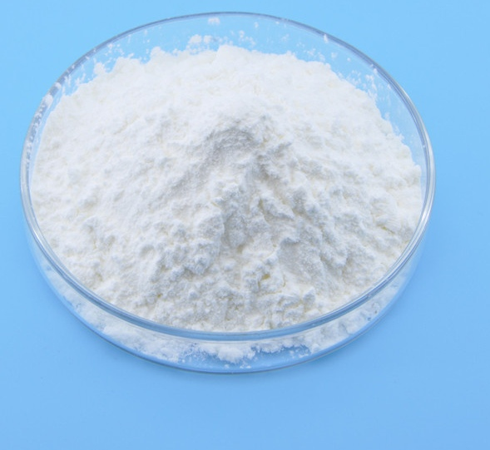
Package: 25Kg per paper bag, with inner PE bag.
Storage: In cool and draught place, no exposure to moisture, heat, fire or corrosion, not pile with acid, Bases and corrosion goods.
​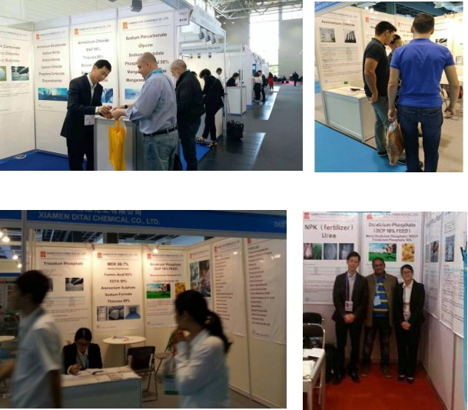
XIAMEN DITAI CHEMICALS CO., LTD
8FL,Hongsheng Building,West Hexiang Road,Xiamen, China
ISO9001:2015 Certificated

